MANANSALA, JOHN PAUL U. IAS 101
BSCS 3A MR. CHRISTIAN TORRES

Midterm Activity 1

Instructions: Infographic on Cybersecurity Awareness Objective: To enhance understanding of key cybersecurity concepts and promote awareness through the creation of a visually engaging and informative infographic.

Topic selection or choose one specific aspect of Cyber Security Awareness.

“SAFE SOCIAL MEDIA USAGE”
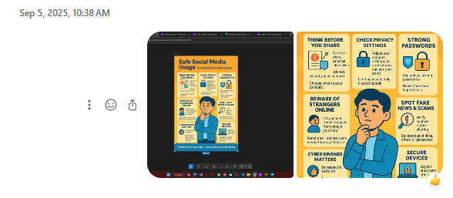

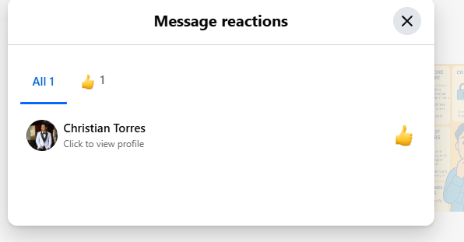
1 React = 2 pts
1 Share = 3 pts

Computations:
Total Reacts – 88 x 2 =176
Total Shares – 275 x 3 = 825
Total Points = 1,001

Posting
Approved

